Calorimetry
Adapted from: “I Cubed year two calorimetry experiment” (L. Kirkham, personal communication, May 30, 2013) and Wassel, A. Lobsiger, S., & Bilodeau, C. (n.d.) “Food As Fuel” Retrieved from http://prezi.com/ghkwswzilwgb/pbl-project/

Objectives:
Use a simple calorimeter to determine:
- The energy content of a cellulosic biomass sample (cotton ball)
- The energy content of second biomass material

Materials:
Ring stand | 0.5-1.0g of biomass samples (e.g., cotton ball, wood shavings)
1 clamp | 25 mL graduated cylinder
Thermometer | Beakers (1-600 mL, 1-250 mL)
Large sheet aluminum foil | Wire mesh (4in x 4in square)
Distilled water | Lab balance
Fireplace matches | 18 x 150 mm test tube
Glass stirring rod | Forceps or tweezers to handle sample residues

Safety Notes:
Handle the wire mesh carefully to avoid getting cut or pricked. Handle heated glassware and wire mesh carefully to avoid burns. Use tongs or test tube holders if necessary. If a fume hood is available, carry the experiment out in the fume hood.

Procedure:
- Place the empty 250 mL beaker on the balance and tare (zero) the balance. Place the empty test tube in the beaker and record its mass to the nearest 0.01 g.
- Use the graduated cylinder to measure out 20 mL of water and transfer it to the test tube. Place the filled test tube in the beaker on the balance and record its mass to the nearest 0.01 g.
- Use the clamp to attach the test tube of water to the ring stand.
- Obtain a cotton ball. After ensuring that the balance is empty and tared, place the 600 mL beaker on the balance. Put the wire mesh on top of the beaker. Record the mass of this setup to the nearest 0.01 g. Place the cotton ball on top of the mesh and determine the mass of the combined items (beaker, mesh, cotton ball) to the nearest 0.01g. Calculate the mass of the cotton ball.
- Place the beaker/wire mesh/ cotton ball set up under the test tube water and adjust the height of the test tube so that the bottom of the tube is approximately 0.5 cm above the cotton ball. See Figure 1 for an illustration of the correct setup.

Figure 1.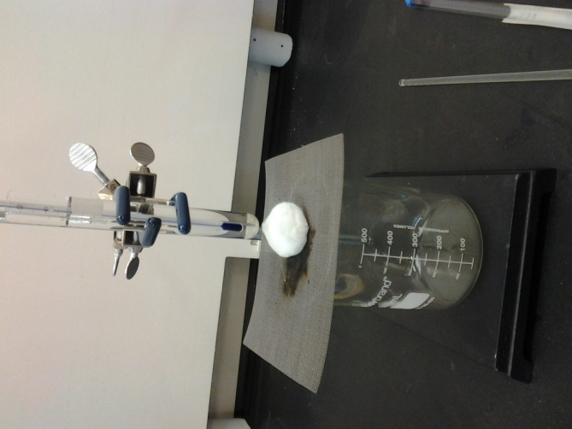

- Insert the thermometer in the test tube of water to the immersion mark. Record the initial temperature of the water to the nearest 0.1 degree. Remove the thermometer.
- Obtain a match and use the match to ignite the cotton ball. Relight as needed to burn the cotton ball completely. Use the glass stirring rod to stir the water as the sample burns. Use the aluminum foil to form a loose wrap (open ends facing experimenter) around the apparatus as the sample burns so that burned sample does not get blown away by the fume hood.
- Record the temperature of the water once the cotton ball has burned completely. Do this quickly to avoid heat loss once the sample has completely combusted. Calculate the temperature change of the water.
- Obtain the mass of the beaker, wire mesh, and any sample residue to the nearest 0.01 g and determine the mass of any residue. Calculate the amount of cotton that burned. Be careful, the wire mesh and beaker may be hot. Use tongs if necessary.
- Once the test tube has cooled, repeat the procedure with a second biomass sample.

Data Table:
 | Sample 1 (cotton ball) | Sample 2:_____________________
Mass of empty test tube (g)
Mass of test tube with water (g)
Mass of water (g)
Mass of beaker and wire mesh (g)
Mass of beaker, wire mesh, and sample (g)
Mass of sample (g)
Initial temperature of water (°C)
Temperature of water after sample burned (°C)
Change in temperature of the water (°C)
Mass of beaker, wire mesh, and sample residue (g)
Mass of sample residue (g)
Mass of sample that burned (g)
Energy content of the sample (kcal)
Energy content per gram of the sample (kcal/gram)
Calculations:
The specific heat capacity of water is 1.00 calorie/ g °C.
Calculate the amount of heat, in calories, that was transferred to the water from the burning sample.
Heat (in calories) = mass of water x specific heat capacity of water x temperature change of water
Sample 1 calculation:

Sample 2 calculation:

Convert this to kilocalories (1 kcal = 1000 cal)
Sample 1 calculation:

Sample 2 calculation:

This is the energy content of the sample that you burned. Record this in the data table.
Calculate the energy content per gram of each sample. Record this in the data table.
Sample 1 calculation:

Sample 2 calculation:

Discussion Questions:
- Other than “mistakes” or “experimental error” suggest at least 2 factors that may have affected the accuracy of your results.

- What happened to the heat that was not transferred to the water?

- Suggest one way to improve the accuracy of your results.

- What other questions might you ask your students to help their understanding of biofuels concepts and/or your content area? (For example, How do we know that that energy used to heat the water was also the energy content of the sample?)

